Dear AUSCI Members and Fellow Trojans,

Selamat Tahun Baru 2011! Terima kasih banyak! I want to take this opportunity to thank you once again for your continued support of The World is Just a Book Away and the children we serve in Indonesia. In particular, I would like to thank Pak Husodo, Holip, Andru, Vanessa, Novita, and all the AUSCI board and charity ball board members for their tireless work in creating such an amazing event.

It was a great honor to speak at the AUSCI event in Jakarta. I enjoyed meeting many of you and I look forward to meeting many more AUSCI members in the future. AUSCI’s commitment through its “Cerdas Bang!” program to reach children through 50 libraries is indeed indicative of AUSCI members’ generosity, commitment to children, and the general excellence of the Trojan family.

As you know, your efforts succeeded, between 2009 and 2010, in raising funds for 18 libraries in Indonesia. WIJABA also named its largest project and program to date, The World is Just a Book Away AUSCI mobile library, in honor of our partnership. Collectively, these projects reach thousands of children with more than 10,000 books. I think that we can all feel proud in the knowledge that this work has forever changed the lives of the children touched through the libraries and mobile library.

As a non-profit raising money in the midst of one of the deepest global economic crises, we of course face many challenges; however, your support in Indonesia has deeply impressed donors in the United States and around the world, which has greatly aided in our efforts to raise funds to assist the children in Indonesia.

As you may also know, WIJABA’s commitment in Indonesia is constructed on the cornerstone belief of long-term commitment to the children, the schools, their families, and their communities. As such, and based upon the strategic benchmarking studies carried out for us, we realized that the long term success of the libraries hinges on long-term partnership and running successful programs through the libraries. I am excited to let you know that we will be launching programs through the WIJABA libraries in Indonesia in 2011.

The next The World is Just a Book Away AUSCI libraries will be launched in the Padang region in 2011 and we hope that many of you will have the pleasure of attending opening ceremonies, which would also be a great honor for us and the children.

The Trojan Family also decided to honor our work and our partnership with AUSCI through two articles, one published through the Marshall School of Business and one through USC. I am including the links to these articles below.

I look forward to hearing from you with any questions, comments or suggestions. I am also grateful and honored by the continued partnership between WIJABA and AUSCI.

Terima kasih and fight on!

Sincerely,

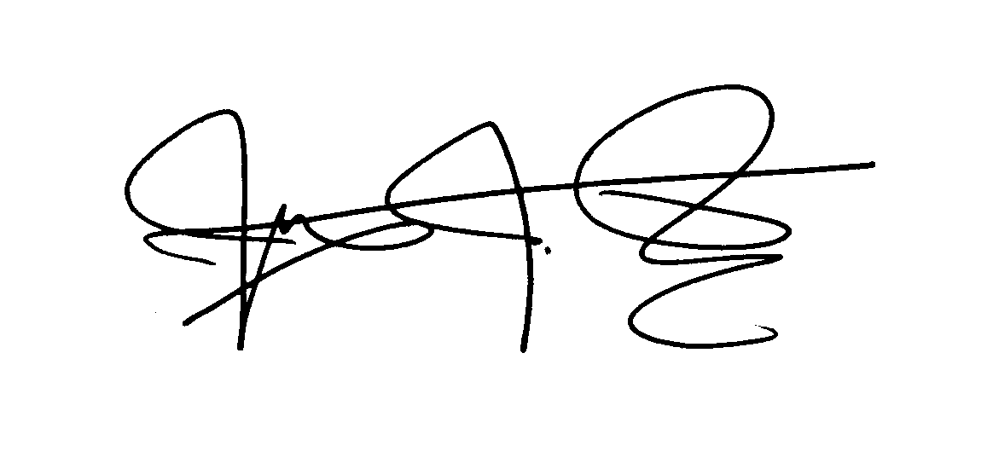
James J. Owens
President & CEO
The World is Just a Book Away
911 Montana Ave Suite C
Santa Monica, CA 90403
USA

“Together we change the world.”

Please visit www.justabookaway.org for more information.

Facebook: http://www.facebook.com/pages/TheWorldisJustaBookAway/122623061121721
Twitter @ justabookaway
Blog: http://www.justabookaway.org/blog/

WIJABA articles published through USC:

http://www.marshall.usc.edu/news/all-articles/all-in-the.htm

http://uscnews.usc.edu/global/usc_marshall-based_nonprofit_reaches_global_scale.html

